

New Hope

Safeguarding Adult’s Policy

1 AIM

The purpose of the New Hope Safeguarding Adult’s Policy is to outline the duty and responsibility of staff, volunteers and trustees working on behalf of the organisation in relation to Safeguarding Adults.

“Safeguarding means protecting people’s health, wellbeing and human rights, and enabling them to live free from harm, abuse and neglect. It’s fundamental to high quality health and social care” (CQC June 2015)

Living a life that is free from harm and abuse is a fundamental right of every person. All of us need to act as good neighbours and citizens in looking out for one another and seeking to prevent isolation, which can easily lead to abusive situations and put adults at risk of harm.
When abuse does take place, it needs to be dealt with swiftly, effectively and in ways which are proportionate to the issues and where the adult in need of protection stays as much in control of the decision-making as is possible. The right of the individual to be heard throughout this process is a critical element in the drive towards more personalised care and support.

Policy Statement on Safeguarding
New Hope is fully committed to safeguarding the welfare of all ‘individuals with care and support needs’ (young adults) and children under the age of 18 years by taking all reasonable steps to protect them from the following forms of abuse. The types of abuse recognised by the Care Act 2014 for individuals with care and support needs aged 18 years or over are: Physical, Psychological, Sexual, Financial, Domestic Violence, Modern Slavery, Neglect, Organisational, Discriminatory and Self-Neglect. The four categories of child abuse are the following listed: Neglect, Physical Abuse, Sexual Abuse and Emotional Abuse. Also, safeguarding all individuals with care and support needs (young adults), that have various complex learning disabilities that we work with, regardless of their gender, sexual orientation, race, nationality or country of origin.

Our prime responsibility is to protect the safety and well-being of all individuals with care and support needs in our care. New Hope staff (support workers), volunteers and students will at all times show respect and understanding for the rights, safety and welfare of the individuals with care and support needs (young adults) involved within New Hope.
We will ensure that staff and volunteers know how to recognise and respond to concerns that they have observed or heard. All New Hope staff (support workers) will receive training i.e. Adult Safeguarding, Recognising, Responding, Enquiring and Reporting and Record Keeping and Data, so they feel competent in the step by step process of how to respond and report a safeguarding concern. Volunteers/ student placement workers will be required to read New Hope Safeguarding Policy and the Care Act 2014 in order to ensure that they have sufficient knowledge and understanding of individuals with care and support needs.

New Hope will review policies and procedures on an annual basis or earlier if necessary to ensure that we are up to date with current legislation and best practice.
All those who come into contact with individuals with care and support needs (young adults); children and families in their work, including people who do not have a specific role in relation to child/adult protection, have a duty to safeguard and promote the welfare of individuals with care and support needs.

All members of the organisation will be aware of their individual roles and understand the procedures they must follow if they suspect abuse or neglect. For example, New Hope will display Adult Safeguarding flow charts that will be visual and accessible to staff members, volunteers, students and individuals with care and support needs (young adults). The safeguarding flow charts will be located in the office for viewing (see appendix A for examples of safeguarding flow charts). The appropriate procedures will be in place in order to protect the individuals with care and support needs, children parents and carers. Our safeguarding adult’s procedures comply with all relevant legislation and other guidance or advice from Worcestershire Safeguarding Adults Board.

Multi-Agency Approach:
We will work together with other agencies including Local Authority Social Care teams and Access Centre to assist in investigations of suspicion of abuse, according to our statutory responsibility and with the aim of protecting individuals with care and support needs. New Hope will ensure to build partnerships and strong working connections with external agencies to ensure to safeguard the individuals with care and support needs to a high standard. Also, New Hope will provide an effective response to any circumstances giving ground for concern, complaints or expressions of anxiety.

New Hope has a children’s safeguarding policy this can be viewed on the web site (www.newhopeworcester.co.uk) All staff are trained in Safeguarding practices and procedures both for Adults and Children.

Safeguarding duties apply to an adult who:
- Has needs for care and support (whether or not the local authority is meeting any of those needs) and;
- Is experiencing, or at risk of, abuse or neglect; and
- As a result of those care and support needs is unable to protect themselves from either the risk of, or the experience of abuse or neglect.

The aim of adult safeguarding is to:
- Stop abuse or neglect wherever possible;
- Prevent harm and reduce the risk of abuse or neglect to adult’s with care and support needs;
- Safeguard adults in a way that supports them in making choices and having control about how they want to live;
- Promote an approach that concentrates on improving life for the adults concerned;
- Provide information and support in accessible ways to help service users understand the different types of abuse, how to stay safe and what to do to raise a concern;
- Address what has caused the abuse or neglect.

2 OBJECTIVES

  - To explain the responsibilities, the organisation and its staff, volunteers and trustees have in respect of adult protection.

  - To provide staff with an overview of adult protection.

  - To provide a clear procedure that will be implemented where adult protection issues arise.

- This policy is given to all parents/carers and service users upon registration in order that they are aware of New Hope policies & procedures. A copy is also available on our website.

- We will review our policies and procedures on an annual basis or earlier if necessary to ensure that we are up to date with current legislation and best practice.

New Hope is committed to follow the 6 key principles that underpin all adult safeguarding work, as laid out by the Department of Health in their Guidance of the Care Standards Act 2000. The 6 key principles to adult safeguarding are listed in the table below.

Empowerment | Individual with care and support needs (young adult) feeling empowered and having the control to make their own decisions and informed consent. However, depending on the assessment and evaluating whether the individual with care and support needs has the capacity to make appropriate decisions.
Prevention | It is always preferable to take action before harm occurs.
Proportionality | Proportionate and least intrusive response appropriate to the risk presented.
Protection | Support and representation for those in greatest need.
Partnership | Solutions through services working with communities, who can detect, prevent and report abuse and neglect.
Accountability | Accountability and transparency in delivering safeguarding.

Involving young adult in the safeguarding process:

- Gaining consent when appropriate.
- Independent Advocate.
- Autonomous decision making.
- Supported decision making.
- Giving clear information to the adult.
- Finding out the adults preferred outcome, it may be not be possible but essential to ask.
- Ensuring the safeguarding plan for the individual with care and support needs is fully explained to them and their advocate or representative.

3 CONTEXT

What do we mean by abuse?

- Abuse of an adult may consist of a single act or repeated acts. It may occur as a result of a failure to undertake action or appropriate care tasks. It may be an act of neglect or an omission to act, or it may occur where a vulnerable person is persuaded to enter into a financial or sexual transaction to which they have not, or cannot, consent. Abuse can occur in any relationship and may result in significant harm to, or exploitation of the individual.

- Concerns about abuse may be raised and reported to the social services agency as a result of a single incident or repeated incidents of abuse. However, for some clients the issues of abuse relate to neglect and poor standards of care. They are ongoing and if ignored may result in a severe deterioration in both physical and mental health and even death.

- Anyone who has concerns about poor care standards and neglect in a care setting may raise these within the service, with the regulatory body and/or with the social services agency.

- Where these concerns relate to an adult living in their own home, with family or with informal carers they must be reported to the social services agency. These reports must be addressed through the adult protection process and a risk assessment must be undertaken to determine an appropriate response to reduce or remove the risk

The Importance of Mental Capacity

- The presumption is that adults have the mental capacity to make informed choices about their own safety and how they live their lives. Issues of mental capacity and the ability to give informed consent are central to decisions and actions in Safeguarding Adults. All interventions need to take into account the ability of adults to make informed choices about the way they want to live and the risks they want to take. This includes their ability:
- To understand the implications of their situation
- To take action themselves to prevent abuse
- To participate to the fullest extent possible in decision-making about interventions.

- The MCA 2005 provides a statutory framework to empower and protect people who may lack capacity to make decisions for them and establishes a framework for making decisions on their behalf. This applies whether the decisions are life-changing events or everyday matters. All decisions taken in the Safeguarding Adults process must comply with the Act.2

Consent
- It is always essential in safeguarding to consider whether the adult at risk is capable of giving informed consent in all aspects of their life. If they are able, their consent should be sought. This may be in relation to whether they give consent to:

- An activity that may be abusive – if consent to abuse or neglect was given under duress (e.g. as a result of exploitation, pressure, fear or intimidation), this apparent consent should be disregarded.
- A Safeguarding Adults investigation/assessment going ahead in response to a concern that has been raised. Where an adult at risk with capacity has made a decision that they do not want action to be taken and there are no public interest or vital interest considerations, their wishes must be respected.

- Person must be given information and have the opportunity to consider all the risks and fully understand the likely consequences of that decision over the short and long term.

- The recommendations of an individual protection plan being put in place.
- A medical examination.
- An interview.
- Certain decisions and actions taken during the Safeguarding Adults process with the person or with people who know about their abuse and its impact on the adult at risk.

- If, after discussion with the adult at risk who has mental capacity, they refuse any intervention, their wishes will be respected unless:
- There is an aspect of public interest (e.g. not acting will put other adults or children at risk)
- There is a duty of care on a particular agency to intervene for example the police if a crime has been or may be committed).

Who is included under the heading 'adult?'

- An Adult (a person aged 18 or over) who 'is or may be in need of community care services by reason of mental or other disability, age or illness; and who is or may be unable to take care of him or herself, or unable to protect him or herself against significant harm or exploitation'.

- This could include people with learning disabilities, mental health problems, older people and people with a physical disability or impairment. It is important to include people whose condition and subsequent vulnerability fluctuates. It may include an individual who may be vulnerable as a consequence of their role as a carer in relation to any of the above.

- It may also include victims of domestic abuse, hate crime and anti-social abuse behavior. The persons’ need for additional support to protect themselves may be increased when complicated by additional factors, such as, physical frailty or chronic illness, sensory impairment, challenging behavior, drug or alcohol problems, social or emotional problems, poverty or homelessness.

- Many adults may not realize that they are being abused. For instance an elderly person, accepting that they are dependent on their family, may feel that they must tolerate losing control of their finances or their physical environment. They may be reluctant to assert themselves for fear of upsetting their carers or making the situation worse.

It is important to consider the meaning of 'Significant Harm'. The Law Commission, in its consultation document 'Who Decides,' issued in Dec 1997 suggested that; 'harm' must be taken to include not only ill treatment (including sexual abuse and forms of ill treatment which are not physical), but also 'the impairment of, or an avoidable deterioration in, physical or mental health; and the impairment of physical, intellectual, emotional, social or behavioral development'.

4 LEGAL FRAMEWORK
All New Hope staff must work within the framework of the law and behaviour which is unlawful will not be condoned in any manner. This will lead to appropriate action being taken against those staff members who have been conducting themselves or behaving outside the framework of the law.

Legal framework listed below:

  - Human Rights Act 1998, the Mental Capacity Act 2005 and Public Interest Disclosure Act 1998.

  - Data Protection Act 1998, Freedom of Information Act 2000, Safeguarding Vulnerable Groups Act 2006, Deprivation of Liberty Safeguards, Code of Practice2008

  - The Mental Capacity Act 2005, covering England and Wales, provides a statutory framework for people who lack capacity to make decisions for themselves, or who have capacity and want to make preparations for a time when they may lack capacity in the future. It sets out who can take decisions, in which situations, and how they must go about this.

  - The Human Rights Act 1998 gives legal effect in the UK to the fundamental rights and freedoms contained in the European Convention on Human Rights (ECHR).

  - The Public Interest Disclosure Act 1998 (PIDA) created a framework for whistle blowing across the private, public and voluntary sectors. The Act provides almost every individual in the workplace with protection from victimisation where they raise genuine concerns about malpractice in accordance with the Act’s provisions.

  - The Care Act 2014 puts adult safeguarding on a legal footing.

5 THE ROLE OF STAFF, VOLUNTEERS AND TRUSTEES

  - All staff, volunteers and trustees working on behalf of the organisation have a duty to promote the welfare and safety of adults who attend New Hope.

  - Staff, volunteers and trustees may receive disclosures of abuse and observe adults who are at risk. This policy will enable staff/volunteers to make informed and confident responses to specific adult protection issues.

As a support worker/Volunteer working with adults, staff are in a unique position to observe any changes in a young person’s behaviour or appearance. You may be someone an adult will turn to for support. You must prepare yourself and be ready to act on any concerns.
- You will have received and read a copy of the Safeguarding policy as part of your induction.
- You will undertake mandatory induction training and regular ongoing training appropriate to your role in relation to safeguarding issues.
- You will adopt safe working practices.
- Staff will be mindful of how and where they touch adults who attend New Hope Lodge, given their age and emotional understanding.
- Unnecessary or potentially inappropriate physical contact will be avoided at all times.
As a Deputy Manager with responsibility for staff and volunteers, you have a responsibility to create a safe environment for all. This means creating an environment where:
- Staff are vigilant to concerns about the welfare and protection of adults who attend New Hope and know what action to take when necessary.
- There is no negligence or unnecessary exposure to avoidable risks.
- The risks that you do need to take are assessed, carefully managed and communicated to adults attending New Hope and their parents/carers.
- Users of the service can raise concerns.
As New Hope Manager with day to day responsibility for all the clubs and the organisation, you have a responsibility to ensure
- The Manager will ensure that policies are implemented by all staff.
- The Manager will ensure that appropriate supervision and management support is provided to staff as appropriate to their responsibilities in relation to Safeguarding.
- Sufficient resources are available to enable the staff to discharge their responsibilities with regard to safeguarding.
- Staff and volunteers are able to raise concerns about poor or unsafe practice and have their concerns addressed in a sensitive, effective and timely way.
- There are safe recruitment and selection practices.
- The Manager will undertake the role Designated Senior Lead for Safeguarding and the Deputy manager will act as deputy DSL.
In addition to the above, the Designated Safeguarding Lead (DSL) responsibilities will;
- Take responsibility for disseminating and implementing Safeguarding Procedures within the organisation/club.
- Ensure that an up to date copy of this policy is available on the policy section of our website (www.newhopeworcester.co.uk).
- Be familiar with WSAB (Worcestershire Safeguarding Adults Board) procedures for safeguarding and investigating suspected abuse.
- Know the relevant contacts within Adult Social Services and be familiar with Adult Social care and Police procedures for investigating abuse.
- Be available to receive information from staff, volunteers, trustees, vulnerable adults, parents and carers about safeguarding issues including any allegations against staff or volunteers.
- Access information promptly and take appropriate action.
- Refer safeguarding concerns to Adult Social Care – 01905 768053 (reporting Concerns) or for advice on safeguarding issues contact the Adult Safeguarding Team on 01905 822613/4.
- Ensure that the user of the service and their parents/carers are offered appropriate support.
- Maintain records of all information received.
- Monitor safeguarding concerns and report at trustee meeting as part of the Managers report.
- Monitor all safeguarding procedures;
- Checking that a parent/carer consent form for every user of the service is completed and stored safely.
- Checking that safe recruitment and selection procedures are followed.
- Checking that safeguarding awareness training is undertaken so that staff’s, including volunteers/trustees, know how to recognise and respond to concerns about a user of the service.
- How to recognise and respond to concerns about an adult who uses the service.
- Offer advice, guidance and support to staff and volunteers/trustees/directors dealing with safeguarding
- Identify training needs and ensure that training is organised.
Relevant Provision Policies, procedures and responsibilities

The following arrangements and related policies ensure all adults are protected:
- Recruitment and Selection Procedures: All staff including volunteers/trustees and student placements working with the adults undergo rigorous recruitment, selection and retention procedures to ensure they are suitable to work with adults who use the service. New Hope will provide all potential directors/trustees, staff and volunteers with job descriptions and a person specification. All interested parties will be required to complete an application form; we will require two references and proof of identity. All directors/trustees, staff and volunteers will be required to attend an interview and complete a DBS disclosure. Once appointed all staff will receive an induction, on-going support and training and confidential records will be kept for each person. Applicants for posts at New Hope are informed that the post is exempt from the rehabilitation of offenders 1974 Act and all convictions, both spent and unspent, must be disclosed. Known offenders are excluded.
- Health and Safety Policy, including risk assessments and daily routine checks on equipment etc, in order to project the young adults, staff members, parents/carers, visitors and volunteers.

- Equal Opportunities Policy Parents/carers, young adults, staff members and volunteers will all be treated with equal opportunities and NOT be discriminated against, and be provided with the opportunity to discuss any concerns with the manager and during team meetings, evaluation forms, discussion time, emotion corner and other communication methods the manager implements. New Hope equal opportunities policy document will be accessible via the www.newhopeworcester.co.uk webpage.

- Code of Staff Conduct; Staff conduct is explained in the staff handbook and given to all new staff on induction. This code includes a commitment to all the provision policies and procedures.

- Visitors; All visitors must sign in a Visitors book. No adults, other than staff are ever left unattended with the users of our service. Any person visiting the provision in an official capacity, not previously known to staff, are required to provide proof of identity.

- Collection of service users: No person is ever allowed to leave the provision with an adult who is not their normal collector without prior permission being obtained.

- Complaints Policy: The organisation will make the complaints policy available at the venue for parent/carers to be aware of and use where necessary. The organisation will take seriously all complaints, concerns and feedback, from parents, carers, staff and service users, and will respond appropriately recording all complaints and outcomes. Records of all complaints are kept for three years.

- Whistle blowing policy: Explaining what staff member should do if they are concerned about practice within the organisation.

- Anti-bullying Policy: New Hope is committed to providing a caring, friendly and safe environment for all young people and staff. Intimidation, harassment and bullying will not be tolerated

- Physical Intervention Policy: In order to keep young people safe we use Team Teach / MAPPA as our approved method of Physical Intervention.

- Disciplinary procedures; to be implemented in the event of investigation.

- Record keeping: The manager will ensure appropriate records are kept up to date and in the right place. Confidential records are to be kept separate and in locked accommodation. Access to records to be limited/controlled e.g. Director of New Hope, Manager and Office Manager.

- Information sharing: We will base our information sharing decisions on considerations of safety and well-being of the person and others who may be affected by their actions. We will ensure that the information we share is necessary for the purpose for which we are sharing it, is shared only with those people who need to have it, is accurate and up-to-date, is shared in a timely fashion, and is shared securely.

- Liaison: We will work in partnership with parent/carers to make every effort to get to know the service users and understand their needs and behaviours.

6 TYPES OF ABUSE
For the purpose of the Safeguarding Adults policy and procedures the term abuse is defined as: A violation of an individual’s human and civil rights by any other person or persons.
Department of Health issued a document Care and Support Statutory Guidance-issued under the Care Act 2014 that outlines the categories of abuse. The types of abuse in relation to individuals with care and support needs (young adults aged 18 and over) are listed as followed below:

Abuse may be:
• A single act or repeated acts.
• An act of neglect or a failure to act.
• Multiple acts (e.g. an adult at risk may be neglected and financially abused).

Abuse is about the misuse of the power and control that one person has over another. Where there is dependency, there is a possibility of abuse or neglect unless adequate safeguards are put in place. Intent is not necessarily an issue at the point of deciding whether an act or a failure to act is abuse; it is the impact of the act on the person and the harm or risk of harm to that individual. Abuse can take place anywhere: a person’s own home, day or residential centres, supported housing, educational establishments, nursing homes, clinics and hospitals. A number of abusive acts are crimes and informing the police must be a key consideration.

Location of abuse
Abuse can take place anywhere. For example:
• The person’s own home, whether living alone, with relatives or others
• Day or residential centres
• supported housing
• work settings
• Educational establishments
• Nursing homes
• Clinics
• Hospitals
• Prisons
• Other places in the community.

Who might abuse?
Abuse can occur in any relationship and may result in significant harm to, or exploitation of, the adult at risk. A wide range of people may harm adults. These include:

• A member of staff, owner or manager at a residential or nursing home
• A professional worker such as a nurse, social worker or general practitioner (GP)
• A volunteer or member of a ‘community group’ such as a social club or place of worship
• Another service user
• A spouse, partner, relative or friend
• A carer
• A neighbour, member of the public or a stranger
• A person who deliberately targets adults at risk in order to exploit them.

Significant harm
In determining what justifies intervention and what sort of intervention is required,
• Ill treatment (including sexual abuse and forms of ill treatment which are not physical)
• The impairment of, or an avoidable deterioration in, physical or mental health, and/or
• The impairment of physical, intellectual, emotional, social or behavioural development.

The importance of this definition is that, in deciding what action to take, consideration must be given not only to the immediate impact on and risk to the person, but also to the risk of future, longer-term harm.
Seriousness of harm, or the extent of the abuse, is not always clear at the point of the alert or referral. All reports of suspicions or concerns should be approached with an open mind and could give rise to action under the Safeguarding Adults policy and procedure.
It should be noted that Department of Health statutory guidance - on eligibility for help from social services – refers to ‘serious abuse or neglect’ in the critical category of eligibility, and to ‘abuse or neglect’ in the substantial category. Since the vast majority of local authorities have decided to assist people whose needs fall into both the critical and substantial categories, it follows that safeguarding is not confined to ‘serious’ abuse or neglect

The following factors to be taken into account when making an assessment of the seriousness of risk to the person: Safeguarding adults: multi-agency policy and procedures:

- vulnerability of the person
- nature and extent of the abuse or neglect
- length of time the abuse or neglect has been occurring
- impact of the alleged abuse on the adult at risk
- risk of repeated or increasingly serious acts of abuse or neglect
- risk that serious harm could result if no action is taken
- Illegality of the act or acts.

In regards to Adult Safeguarding there are 10 categories of Abuse listed below:

Physical Abuse -Physical abuse includes hitting, slapping, pushing, kicking, misuse of medication, being locked in a room, inappropriate sanctions or force-feeding, inappropriate methods of restraint, and unlawfully depriving a person of their liberty.
Possible indicators
- Unexplained or inappropriately explained injuries.
- Person exhibiting untypical self-harm.
- Unexplained cuts or scratches to mouth, lips, gums, eyes or external genitalia.
- Unexplained bruising to the face, torso, arms, back, buttocks, thighs, in various stages of healing. Collections of bruises that form regular patterns correspond to the shape of an object or which appear on several areas of the body.
- Unexplained burns on unlikely areas of the body (e.g. soles of the feet, palms of the hands, back), immersion burns (from scalding in hot water/liquid), rope burns, burns from an electrical appliance.
- Unexplained or inappropriately explained fractures at various stages of healing to any part of the body. Medical problems that go unattended.
- Sudden and unexplained urinary and/ or faecal incontinence.
- Evidence of over-/under-medication.
- Person flinches at physical contact.
- Person appears frightened or subdued in the presence of particular people. Person asks not to be hurt.
- Person may repeat what the alleged abuser has said (e.g. ‘Shut up or I’ll hit you’).
- Reluctance to undress or uncover parts of the body.
- Person wears clothes that cover all parts of their body or specific parts of their body.
- A person without capacity not being allowed to go out of a care home when they ask to.
- A person without capacity not being allowed to be discharged at the request of an unpaid carer/family member.
Psychological/emotional Abuse- Psychological abuse includes ‘emotional abuse’ and takes the form of threats of harm or abandonment, deprivation of contact, humiliation, rejection, blaming, controlling, intimidation, coercion, indifference, harassment, verbal abuse (including shouting or swearing), and isolation or withdrawal from services or support networks.
Psychological abuse is the denial of a person’s human and civil rights including choice and opinion, privacy and dignity and being able to follow one’s own spiritual and cultural beliefs or sexual orientation.
It includes preventing the adult from using services that would otherwise support them and enhance their lives. It also includes the intentional and/or unintentional withholding of information (e.g. information not being available in different formats/languages etc.).

Possible indicators
• Untypical ambivalence, deference, passivity, resignation.
• Person appears anxious or withdrawn, especially in the presence of the alleged abuser.
• Person exhibits low self-esteem.
• Untypical changes in behaviour (e.g. continence problems, sleep disturbance).
• Person is not allowed visitors/phone calls.
• Person is locked in a room/in their home.
• Person is denied access to aids or equipment, (e.g. glasses, dentures, hearing aid, crutches, etc.).
- Person’s access to personal hygiene and toilet is restricted.
- Person’s movement is restricted by use of furniture or other equipment.
- Bullying via social networking internet sites and persistent texting.

Sexual Abuse- Sexual abuse includes rape and sexual assault or sexual acts that the adult at risk has not consented to or could not consent to, or was pressured into.
It includes penetration of any sort, incest and situations where the alleged abuser touches the abused person’s body (e.g. breasts, buttocks, genital area), exposes his or her genitals (possibly encouraging the abused person to touch them) or coerces the abused person into participating in or looking at pornographic videos or photographs. Denial of a sexual life to consenting adults is also considered abusive practice.
Any sexual relationship that develops between adults where one is in a position of trust, power or authority in relation to the other (e.g. day centre worker/social worker/residential worker/health worker etc.) may also constitute sexual abuse.
Possible indicators
• Person has urinary tract infections, vaginal infections or sexually transmitted diseases that are not otherwise explained.
Person appears unusually subdued, withdrawn or has poor concentration.
• Person exhibits significant changes in sexual behaviour or outlook.
• Person experiences pain, itching or bleeding in the genital/anal area.
• Person’s underclothing is torn, stained or bloody.
• A woman who lacks the mental capacity to consent to sexual intercourse becomes pregnant.

Sexual exploitation- The sexual exploitation of adults at risk involves exploitative situations, contexts and relationships where adults at risk (or a third person or persons) receive ‘something’ (e.g. food, accommodation, drugs, alcohol, cigarettes, affection, gifts, money) as a result of performing, and/or others performing on them, sexual activities.
Sexual exploitation can occur through the use of technology without the person’s immediate recognition −this can include, being persuaded to post sexual images on the internet/a mobile phone with no immediate payment or gain or being sent such an image by the person alleged to be causing harm. In all cases those exploiting the adult at risk have power over them by virtue of their age, gender, intellect, physical strength and/or economic or other resources.

Financial or material abuse- This includes theft, fraud, exploitation, pressure in connection with wills or property and the misappropriation of property or benefits. It also includes the withholding of money or the unauthorised or improper use of a person’s money or property, usually to the disadvantage of the person to whom it belongs. Staff borrowing money or objects from a service user is also considered financial abuse.

Possible indicators
• Lack of money, especially after benefit day.
• Inadequately explained withdrawals from accounts.
• Disparity between assets/income and living conditions.
• Power of attorney obtained when the person lacks the capacity to make this decision.
• Recent changes of deeds/title of house.
• Recent acquaintances expressing sudden or disproportionate interest in the person and their money.
• Service user not in control of their direct payment or individualised budget.
• Mis-selling/selling by door-to-door traders/cold calling.
• Illegal money-lending.

Domestic Violence- Domestic abuse is defined as:
‘Any incident or pattern of incidents of controlling, coercive or threatening behaviour, violence or abuse between those aged 16 or over who are or have been intimate partners or family members regardless of gender or sexuality.’ This can encompass, but is not limited to, the following types of abuse:
• Psychological
• Physical
• Sexual
• Financial
• Emotional

‘Controlling behaviour is: a range of acts designed to make a person subordinate and/or dependent by isolating them from sources of support, exploiting their resources and capacities for personal gain, depriving them of the means needed for independence, resistance and escape and regulating their everyday behaviour. Coercive behaviour is: an act or a pattern of acts of assault, threats, humiliation and intimidation or other abuse that is used to harm, punish, or frighten their victim.’

This definition, which is not a legal definition, includes so called 'honour’ based violence, female genital mutilation (FGM) and forced marriage, and is clear that victims are not confined to one gender or ethnic group’8. Family members are defined as mother, father, son, daughter, brother, sister and grandparents, whether directly related, in-laws or step-family. Whatever form it takes, domestic abuse is rarely a one-off incident and should instead be seen as a pattern of abusive and controlling behaviour through which the abuser seeks power over the victim. Domestic abuse occurs across society, regardless of age, gender, race, sexuality, wealth and geography. The figures from reported incidents show, however, that it consists mainly of violence by men against women. Young adults are also affected both directly and indirectly and there is also a strong correlation between domestic violence. 9 Effective safeguarding is achieved when agencies share information to obtain an accurate picture of the risk and then work together to ensure that the safety of the adult at risk is prioritised. In high-risk situations it may be relevant to access the multi-agency risk assessment conference (MARAC) process.
A MARAC is a meeting where information is shared on the highest risk domestic abuse cases between representatives of the local police, probation, health, children and Adults Safeguarding bodies, housing practitioners, substance misuse services, independent domestic violence advisers (IDVAs) and other specialists from the statutory and voluntary sectors.

The four aims of a MARAC are:
• To safeguard adult victims who are at high risk of future domestic violence.
• To make links with other public protection arrangements in relation to children, people causing harm and vulnerable adults.
• To safeguard agency staff.
• To work towards addressing and managing the behaviour of the person causing harm.

Domestic homicide reviews (DHRs) were established on a statutory basis under Section 9 of the Domestic Violence, Crime and Victims Act (DVCVA) 2004. This provision came into force on 13 April 2011 and the purpose is to:
• establish what lessons are to be learned from the domestic homicide regarding the way in which local professionals and organisations work individually and together to safeguard victims.
• identify clearly what those lessons are, both within and between agencies, how and within what timescales they will be acted upon, and what is expected to change as a result
• apply these lessons to service responses including changes to policies and procedures as appropriate.
• prevent domestic homicide and improve service responses for all domestic violence victims and their children through improved intra- and inter-agency working.

DHRs are not inquiries into how the victim died or into who is culpable and are not specifically part of any disciplinary inquiry or process. The rationale for the review process is to ensure agencies are responding appropriately to victims of domestic violence by offering and putting in place:
- Appropriate support mechanisms.
- Procedures.
- Resources and interventions with the aim of avoiding future incidents of domestic homicide and violence.

A DHR will also assess whether agencies have sufficient and robust procedures and protocols in place, which were in turn understood and adhered to by staff. The DHR process is similar to that of adult and children’s serious case reviews (SCRs). The main purpose is to learn lessons.

Honour-based violence
Honour-based violence is a crime, and referring to the police must always be considered. It has or may have been committed when families feel that dishonour has been brought to them. Women are predominantly (but not exclusively) the victims and the violence is often committed with a degree of collusion from family members and/or the community. Many of these victims will contact the police or other organisations. However, many others are so isolated and controlled that they are unable to seek help.
Alerts that may indicate honour-based violence include domestic violence, concerns about forced marriage, enforced house arrest and missing person’s reports. If a concern is raised through a Safeguarding Adults referral, and there is a suspicion that the adult is the victim of honour-based violence, referring to the police must always be considered as they have the necessary expertise to manage the risk.

Modern Slavery- Encompasses slavery, human trafficking, forced labour and domestic servitude. Traffickers and slave masters use whatever means they have at their disposal to coerce, deceive and force individuals into a life of abuse, servitude and inhumane treatment.

Human trafficking (including Modern Slavery)-
Human trafficking involves an act of recruiting, transporting, transferring, harbouring or receiving a person through a use of force, coercion or other means, for the purpose of exploiting them.
If an identified victim of human trafficking is also an adult at risk, the response will be coordinated under the Safeguarding Adults process. The police are the lead agency in managing responses to adults who are the victims of human trafficking.
There is a national framework to assist in the formal identification and help to coordinate the referral of victims to appropriate services, known as the National Referral Mechanism.

Neglect and acts of omission- These include ignoring medical or physical care needs, failure to provide access to appropriate health, social care or educational services, and the withholding of the necessities of life such as medication, adequate nutrition and heating. Neglect also includes a failure to intervene in situations that are dangerous to the person concerned or to others, particularly when the person lacks the mental capacity to assess risk for themselves.
Neglect and poor professional practice may take the form of isolated incidents or pervasive ill treatment and gross misconduct. Neglect of this type may happen within a person’s own home or in an institution. Repeated instances of poor care may be an indication of more serious problems. Neglect can be intentional or unintentional.

Possible indicators
• Person has inadequate heating and/or lighting.
• Person’s physical condition/appearance is poor (e.g. ulcers, pressure sores, soiled or wet clothing).
- Person is malnourished, has sudden or continuous weight loss and/or is dehydrated.
- Person cannot access appropriate medication or medical care.
- Person is not afforded appropriate privacy or dignity.
- Person and/or a carer has inconsistent or reluctant contact with health and social services.
- Callers/visitors are refused access to the person.
- Person is exposed to unacceptable risk.

It should be remembered that, where someone has capacity to make their own decisions in these matters, they may choose not to seek or use such advice or support services. This does not necessarily have a detrimental impact on the legality or safety of the support plan.
People with PBs and support plans which utilise direct payments are subject to the same reviewing arrangements as those in receipt other services (i.e. a minimum of once per year).
Those who fund their own care arrangements are legally entitled to receive support if subject to abuse or neglect in exactly the same way as those supported or funded by the local authority.
Self-neglect does not come under the scope of these procedures – which relate to circumstances where there is a person or agent, other than the adult at risk, who is causing significant harm. However, some local authorities will apply their safeguarding procedures to protect individuals who self-neglect where there is not a person alleged to have caused harm. New Hope will refer such matters to Adult Safeguarding Team on 01905 822613/4.

Organisational/Institutional Abuse-
Institutional abuse is the mistreatment, abuse or neglect of an adult at risk by a regime or individuals in a setting or service where the adult at risk lives or that they use. Such abuse violates the person’s dignity and represents a lack of respect for their human rights.
Institutional abuse occurs when the routines, systems and regimes of an institution result in poor or inadequate standards of care and poor practice which affect the whole setting and deny, restrict or curtail the dignity, privacy, choice, independence or fulfilment of adults at risk.7
Institutional abuse can occur in any setting providing health or social care. A number of inquiries into care in residential settings have highlighted that institutional abuse is most likely to occur when staff:

- Receive little support from management.
- Are inadequately trained.
- Are poorly supervised and poorly supported in their work.
- Receive inadequate guidance.

Such abuse is also more likely where there are inadequate quality assurance and monitoring systems in place.

Possible indicators
• Unnecessary or inappropriate rules and regulations.
• Lack of stimulation or the development of individual interests.
• Inappropriate staff behaviour, such as the development of factions, misuse of drugs or alcohol, failure to respond to leadership.
• Restriction of external contacts or opportunities to socialise.

Discriminatory- This includes discrimination on the grounds of race, faith or religion, age, disability, gender, sexual orientation and political views, along with racist, sexist, homophobic or ageist comments or jokes, or comments and jokes based on a person’s disability or any other form of harassment. It also includes not responding to dietary needs and not providing appropriate spiritual support. Excluding a person from activities on the basis they are ‘not liked’ is also discriminatory abuse.

Possible Indicators
Indicators for discriminatory abuse may not always be obvious and may also be linked to acts of physical abuse and assault, sexual abuse and assault, financial abuse, neglect, psychological abuse and harassment, so all the indicators listed above may apply to discriminatory abuse.
• A person may reject their own cultural background and/or racial origin or other personal beliefs, sexual practices or lifestyle choices.
• A person making complaints about the service not meeting their needs.

Self-Neglect- Self neglect covers a wide range of behaviour neglecting to care for one’s personal hygiene, health or surroundings and includes behaviour such as hoarding.

Self-neglect does not come under the scope of these procedures – which relate to circumstances where there is a person or agent, other than the adult at risk, who is causing significant harm. However, some local authorities will apply their safeguarding procedures to protect individuals who self-neglect where there is not a person alleged to have caused harm. Practitioners should refer to local procedures relating to this issue.
Much abusive behaviour constitutes a criminal offence. All suspected abuse must be investigated. Many situations may involve more than one type of abuse. Consider the definition of each category in turn, together with their indicators. Be aware that the lists given below are only an indication that abuse is happening and disclosure from an individual may also be offered.

The presence of one or more of these signs does not confirm abuse. However, the presence of one or a number of these indicators may suggest the potential for abuse and a safeguarding alert must be made.

Safeguarding Children (Anyone under the age of 18)- 4 categories of child abuse:

- Neglect- The persistent failure to meet a child’s basic physical and/or psychological needs, likely to result in the serious impairment of the child’s health or development. Neglect may occur during pregnancy as a result of maternal substance misuse. Once the child is born, neglect may involve a parent or carer failing to:

- Provide adequate food, clothing and shelter (including exclusion from home or abandonment).
- Protect a child from physical and emotional harm or danger.
- Ensure adequate supervision (including the use of inadequate care-givers), or
- Ensure access to appropriate medical care or treatment.

- Physical Abuse- This form of abuse may involve hitting, shaking, throwing, poisoning, burning, scalding, drowning, suffocating or otherwise causing physical harm to a child. Also, physical harm may be caused when a parent/carer fabricates the symptoms of, or deliberately induces, illness in a child.

- Sexual Abuse- Forcing or enticing a child or young person to take part in sexual activities, not necessarily involving a high level of violence, whether or not the child is aware of what is happening. The activities may involve physical contact, including assault by penetration (for example, rape or oral sex) or non-penetrative acts such as masturbation, kissing, rubbing or touching of outside clothing. They may also include non-contact activities, such as involving children in looking at, or in the production of, sexual images, watching sexual activities, encouraging children to behave in sexually inappropriate ways, or grooming a child in preparation for abuse (including via the internet). Sexual Abuse is not always necessarily associated or perpetrated adult males. Therefore, women can also commit acts of sexual abuse, as well as other children.

- Child Sexual Exploitation (CSE) - Is also a form of sexual abuse. It is the coercion or manipulation of children and young people into taking part in sexual activities, usually involving an exchange of some form, which can include money, mobile phones and other items, drugs, alcohol, a place to stay, protection or affection. The vulnerability of the young person and grooming process employed by perpetrators renders them powerless to recognise the exploitative nature of relationships and unable to give informed consent.

- Emotional Abuse- Causing persistent and emotional adverse effects on a child’s emotional development. It may involve conveying to a child that they are worthless and unloved, inadequate, or valued only insofar as to meet the needs of another person. Also, emotional abuse may involve not giving a child opportunity to express their views, deliberately silencing them or making fun of what they say or how they communicate. Emotional abuse can be associated with age and involve inappropriate expectations being opposed upon the child. These may include interactions that are beyond a child’s developmental capability, as well as overprotection and limitation of exploration and learning, or preventing the child participating in normal social interaction. It may involve seeing or hearing the ill-treatment of another. Also, could potentially involving serious bullying (including cyber-bullying), causing children to frequently feel frightened, threatened or in danger.

Other areas of abuse
In relation to safeguarding adults it is important to recognise other signs of abuse that can occur.

Hate crime
A hate crime is any criminal offence that is motivated by hostility or prejudice based upon the victim's:
- disability
- race
- religion or belief
- sexual orientation
- Transgender identity.

Hate crime can take many forms including:
• Physical attacks such as physical assault, damage to property, offensive graffiti and arson.
• Threat of attack including offensive letters, abusive or obscene telephone calls, groups hanging around to intimidate and unfounded, malicious complaints.
• Verbal abuse, insults or harassment − taunting, offensive leaflets and posters, abusive gestures, dumping of rubbish outside homes or through letterboxes, and bullying at school or in the workplace.

Female genital mutilation
Female genital mutilation (FGM) involves procedures that intentionally alter or injure female genital organs for non-medical reasons. The procedure has no health benefits for girls and women. The Female Genital Mutilation Act (FGMA) was introduced in 2003 and came into effect in March 2004. The Act makes it illegal to practise FGM in the UK or to take girls who are British nationals or permanent residents of the UK abroad for FGM whether or not it is lawful in another country. It also makes it illegal to aid, abet, counsel or procure the carrying out of FGM abroad.

Forced marriage
Forced marriage is a term used to describe a marriage in which one or both of the parties are married without their consent or against their will. A forced marriage differs from an arranged marriage, in which both parties consent to the assistance of their parents or a third party in identifying a spouse.
In a situation where there is concern that an adult at risk is being forced into a marriage they do not or cannot consent to, there will be an overlap between action taken under the forced marriage provisions and the Safeguarding Adults process. In this case action will be coordinated with the police and other relevant organisations.
The police must always be contacted in such cases as urgent action may need to be taken.

Exploitation by radicalisers who promote violence:
Individuals may be susceptible to recruitment into violent extremism by radicalisers. Violent extremists often use a persuasive rationale and charismatic individuals to attract people to their cause. The aim is to attract people to their reasoning, inspire new recruits, embed their extreme views and persuade vulnerable individuals of the legitimacy of their cause. The Home Office leads on the anti-terrorism strategy. This is known as Prevent.

Personal budgets and self-directed care:
Increasingly people are deciding to use less traditional ways of having their eligible social care and health care needs met. Many are taking the opportunity to exercise greater choice and control over what kinds of services they receive, who provides them and the way in which they are delivered. This revolution brings with it opportunities and challenges from the perspective of risk enablement and safeguarding.

Regardless of the person’s preferred method of managing a PB (e.g. council managed account, direct payment, individual service account or a combination of these), the local authority still retains its duty of care with regard to the person and their protection from abuse. However, the balance of power and consequently how risk is managed can be significantly different from previous, traditional, models of social care management. This model is more about the co-production of risk enablement, with the person having a greater say and therefore greater control over how risk is managed. This is therefore an inherently less risk adverse arrangement than before.

Throughout the process, from self-assessment (supported or otherwise) through to PB-setting, arranging direct payments or other PB management arrangements, to final sign-off of a support plan, appropriate risk assessment should be taking place with the individual and their supporters.

At the various key stages in the process, risk and safety should be considered:

• Self-assessment: initial identification of any safeguarding issues, either one-off or ongoing. If these needs are being met, how is this being done? If they are not being met, they need to be clearly identified.

• Budget-setting: if significant safeguarding risks are identified as unmet needs, will the amount of the PB be sufficient to reduce or mitigate them?

• Support planning: how will the support plan meet the safeguarding needs in outcome terms? What services are best suited to meet the person’s needs and how will they be delivered in a person-centred way?

• Sign-off: authorisation of the support to ensure it is legal, safe and affordable.
In this arrangement people using PBs, to a greater or lesser degree, are the commissioners of their own services, particularly where they are using direct payments to manage them.
Different arrangements exist to support people through the process of setting up a support package. In some areas this may be the responsibility of local authority adult social care staff, independent brokerage services or user-led organisations (ULOs). The kinds of support available may include:
• Advice about safe recruitment
• Advice about safeguarding and dignity
• Using approved or accredited providers of services
• Employment advice and services
• Advice and support in relation to the quality of services
• Contractual issues

It should be remembered that, where someone has capacity to make their own decisions in these matters, they may choose not to seek or use such advice or support services. This does not necessarily have a detrimental impact on the legality or safety of the support plan.
People with PBs and support plans which utilise direct payments are subject to the same reviewing arrangements as those in receipt other services (i.e. a minimum of once per year).

Those who fund their own care arrangements
People who fund their own care arrangements are legally entitled to receive support if subject to abuse or neglect in exactly the same way as those supported or funded by the local authority.

PREVENT and the promotion of British values
The Prevent Duty (June 2015, Department of Education) is part of the government’s duty in the counter-terrorism and security Act 2015 on specified authorities, in the exercise of their functions, to have due regard to the need to prevent people from being drawn into terrorism. Visit https://www.gov.uk/government/publications/protecting-children-from-radicalisation-the-prevent-duty for more information. The strategy covers all forms of terrorism, including far right extremism and some aspects of non-violent extremism, and The Home Office works with local authorities, a wide range of government departments, and community organisations to deliver the Prevent strategy. A range of measures is used to challenge extremism in the UK, including supporting people who are at risk of being drawn into terrorist activity through the Channel process, which involves several agencies working together to give individuals access to services such as health and education, specialist mentoring and diversionary activities. Providers should ensure that they promote fundamental British values of democracy, the rule of law, individual liberty and mutual respect and tolerance of those with different faiths and beliefs, and should be aware of potentially vulnerable individuals who may be susceptible to radicalisation.
New Hope always strives to follow new initiatives set down by government which may affect the welfare of the young people and their families who we support and our own staff and volunteers.
The above information sets down guidance regarding people’s possible extremist views which may impact upon the welfare of people with links to New Hope .
New Hope through engaging activities and themed days allow the young people to learn about British traditions and customs and also about those of other cultures and faiths.
If New Hope has concerns for any of its young people, their families or our own staff and volunteers, they will follow normal safeguarding procedure, discussing with the DSL and these concerns will be shared with the Access Centre on: 0845 607 2000 or
01905 768054 Monday – Friday 8.30am-5pm
01905 768020 Out Of Hours (evenings and weekends)
Or If New Hope believes a crime has been committed or likely to be committed the Police will be contacted on 999.
If New Hope are unsure they will seek advice from the West Mercia Prevent team 01386 591835 / 01386 591816 / 01386 591825 prevent@warwickshireandwestmercia.pnn.police.uk

Abuse by another adult at risk:
Where the person causing the harm is also an adult at risk, the safety of the person who may have been abused is paramount. Organisations may also have responsibilities towards the person causing the harm, and certainly will have if they are both in a care setting or have contact because they attend the same place (e.g. a day centre). In this situation, it is important that the needs of the adult at risk who is the alleged victim are addressed separately from the needs of the person allegedly causing harm.
It may be necessary to reassess the adult allegedly causing the harm. This will involve a meeting where the following could be addressed:
• The extent to which the person causing the harm is able to understand his or her actions.
• The extent to which the abuse or neglect reflects the needs of the person causing the harm not being met (e.g. risk assessment recommendations not being met).
• The likelihood that the person causing the harm will further abuse the victim or others.

The principles and responsibilities of reporting a crime apply regardless of whether the person causing harm is deemed to be an adult at risk.

7 CHILDREN

It is essential that the needs of any children within an abusive or domestic violence situation where there is an adult service user involved are considered and acted upon. Please contact New Hope DSL/Deputy DSL. The DSL must immediately inform Children’s Services Access Centre and make a note of the name of the person spoken to. Advice about the management of allegations is available from the Local Authority Designated Officer (LADO) 01905 752800 OR 0780586225

8 Staff & Volunteers receiving appropriate training

New Hope staff will undergo the necessary appropriate training in order to safeguard individuals with care and support needs who use the New Hope services. The New Hope manager (jean Wilson) will ensure that new staff are enrolled onto an adult safeguarding course and existing members of staff renew their safeguarding training (i.e. Adult Safeguarding: Recognizing, Responding, Enquiring and Reporting Course). The Adult safeguarding course will help the staff to recognize early signs of abuse, understand how to communicate effectively and report concerns to adult safeguarding and other linked agencies.
If New Hope staff members have a safeguarding concern then all abuse or neglect concerns relating to adults with care and support needs should be reported to ‘Worcestershire County Council Adults Social Care via the online form on the ‘Your Life, Your Choice website. The ‘Your Life, Your Choice’ link can be accessed by clicking http://ylyc.worcestershire.gov.uk and press the ‘Worried About Someone’ to access the form accordingly. In exceptional circumstances, whereby assistance or guidance may be required to complete the form then the ‘Access Service’ will assist. They can be contacted on 0845 607 2000. Also, in more serious cases of an adult safeguarding concern of abuse or neglect or a criminal offense has occurred or may occur then the ‘West Mercia Police’ must be contacted immediately. However, if a crime is in progress or life is at risk, dial emergency 999 and then make the referral to Adult Social Care. If a child is identified as being at risk of harm, refer to children’s services as soon as possible (Worcester Children’s Services-0845 607 2000). Also the Care Quality Commission (CQC) must be notified if a safeguarding concern occurs. The Care Quality Commission number is: 03000616161.

The manager will supervise all staff to ensure they feel competent and confident if they are faced with a safeguarding issue or concern. The manager will check employee’s competencies by reviewing their professional practice through observation, question sheets and informal discussions. This will help to ensure that staff members feel confident in relation to safeguarding individuals with care and support needs.

Diagrams labeled in the appendices will inform staff of the necessary steps of how to report a safeguarding concern and what procedures to follow. It is very important for staff members to immediately report a safeguarding concern in order to safeguard the wellness of the young adults and children.
.

Staff Reviewing Policies

The manager of New Hope will ensure that staff members will review all written policies and procedure including the Safeguarding policy. Policies and procedures will be reviewed a read by staff every year to ensure that they are aware of any changes made to the policies and procedures. Staff will be required to sign and date each policy to agree that they have read and understood the policies. Also, any new members of staff will be required to read all policies and procedures before engaging/supporting the young adults or any form of work. This is to ensure that new staff members who have been recruited know how to adhere to the policies and procedures in order to safeguard young adults and children.

Also, New Hope manager will update staff members of any changes so they are kept updated. Staff members will be provided with question sheets which will outline various questions in relation to safeguarding. This will test staff members knowledge and understanding to ensure that they understand safeguarding, how to raise a concern, how to evidence and report a safeguarding concern correctly.

9 PROCEDURE IN THE EVENT OF A DISCLOSURE

  - It is important that adult service users are protected from abuse. All complaints, allegations or suspicions must be taken seriously.

  - This procedure must be followed whenever an allegation of abuse is made or when there is a suspicion that an adult has been abused.

  - Promises of confidentiality must not be given as this may conflict with the need to ensure the safety and welfare of the individual.

  - A full record shall be made as soon as possible of the nature of the allegation and any other relevant information.

  - This must include information in relation to the date, the time, the place where the alleged abuse happened, your name and the names of others present, the name of the complainant and, where different, the name of the adult who has allegedly been abused, the nature of the alleged abuse, a description of any injuries observed, the account which has been given of the allegation.

10 RESPONDING TO AN ALLEGATION

  - Any suspicion, allegation or incident of abuse must be reported to the Designated Safeguarding Lead on that working day where possible.

  - The DSL shall telephone and report the matter to the appropriate local adult social services team on 01905 768053 or for advice on safeguarding issues call Adult Safeguarding team on 01905 822613/4 A written record of the date and time of the report shall be made and the report must include the name and position of the person to whom the matter is reported. The telephone report must be confirmed in writing to the relevant local authority adult social services department within 24 hours.

Responding to allegations against carers who are relatives or friends
There is a clear difference between unintentional harm caused inadvertently and a deliberate act of either harm or omission, however contact must be made with the police, if a crime has been or may be committed.

In cases where unintentional harm has occurred this may be due to lack of knowledge or due to the fact that the carer’s own physical or mental needs make them unable to care adequately for the adult at risk. The carer may also be an adult at risk. In this situation the aim of Safeguarding Adults work will be to help the carer to provide support and make changes in their behaviour in order to decrease the risk of further harm to the person they are caring for.

A carer’s assessment should follow the legal requirements of the Carers and Disabled Children Act 2000 and take into account the following factors:
- Whether the adult for whom they care has a learning disability, mental health problems or a chronic progressive disabling illness that creates caring needs which exceed the carer’s ability to meet them.
- The emotional and/or social isolation of the carer and the adult at risk.
- Whether there is minimal or no communication between the adult at risk and the carer either through choice, mental incapacity or poor relationship
- Whether the carer is or is not in receipt of any practical and/or emotional support from other family members or professionals.
- Financial difficulties.
- Whether the carer has an enduring or lasting power of attorney or appointeeship
- Whether there is a personal or family history of violent behaviour, alcoholism, substance misuse or mental illness.
- The physical and mental health and wellbeing of the carer.

.
Responding to allegations against persons in a position of trust (including Staff/volunteers/trustees)
For the purposes of this policy a person in a position of trust (PIPOT) is someone who works with or cares for adults at risk in a paid or voluntary capacity and about whom allegations of adult abuse or neglect are made. This includes ‘shared lives carers’ (previously known as ‘adult foster carers’).
PIPOT local arrangements should be followed in all cases in which there is an allegation or suspicion that a person working with adults at risk has:
• behaved in a way that has harmed or may have harmed an adult at risk
• Possibly committed a criminal offence against or related to an adult at risk
• behaved towards an adult at risk in a way that indicates she or he is unsuitable to work with such adults
• behaved in a way that has harmed children or may have harmed children which means their ability to provide a service to adults at risk must be reviewed
• been subject to abuse themselves, which means their ability to provide a service to adults at risk must be reviewed.

Adults at risk can be subjected to abuse by those who work with them in any and every setting. All allegations of abuse, neglect or maltreatment of adults at risk by a PIPOT must be taken seriously and treated in accordance with consistent procedures. All adults at risk are entitled to the same level and standard of protection from harm, regardless of whether they are receiving statutory or other services or if they are receiving none.
The scope of PIPOT procedures applies to all cases where concern, suspicion or allegation arises in connection with:
• The PIPOT's own work/voluntary activity
• The PIPOT's life outside work (i.e. concerning adults at risk in the family or the social circle, risks to children, whether the individual's own children or other children).

If any parents/carers or their representatives have concerns regarding New Hope Lodge staff (in relation to safeguarding) they can telephone local adult social services team on 01905 768053 or for advice on safeguarding issues call Adult Safeguarding team on 01905 822613/4. They should also alert New Hope’s Lodge manager.

The procedures apply whether the concern is current or historical.

11 RESPONDING APPROPRIATELY TO AN ALLEGATION OF ABUSE

In the event of an incident or disclosure:

DO

- Make sure the individual is safe
- Assess whether emergency services are required and if needed call them
- Listen
- Offer support and reassurance
- Ascertain and establish the basic facts.
- Make careful notes and obtain agreement on them.
- Ensure notation of dates, time and persons present are correct and agreed.
- Take all necessary precautions to preserve forensic evidence.
- Follow correct procedure.
- Explain areas of confidentiality; immediately speak to your manager for
- Support and guidance.
- Explain the procedure to the individual making the allegation.
- Remember the need for ongoing support.

DON’T

- Confront the alleged abuser.
- Be judgmental or voice your own opinion.
- Be dismissive of the concern.
- Investigate or interview beyond that which is necessary to establish the basic facts.
- Disturb or destroy possible forensic evidence.
- Consult with persons not directly involved with the situation.
- Ask leading questions.
- Assume Information.
- Make promises.
- Ignore the allegation.
- Elaborate in your notes.
- Panic.

It is important to remember that the person who first encounters a case of alleged abuse is not responsible for deciding whether abuse has occurred. This is a task for the professional adult protection agencies, following a referral from the designated Adult Protection Officer.

Important Note:
See appendix B and C for further information of the correct procedure and action to be taken when a safeguarding concern occurs.

12 Whistle-Blower
New Hope staff members should act as whistle blowers if they witness or have been informed of a safeguarding concern/issue of abuse or neglect. Staff members acting as a whistle-blower have the duty to report certain types of wrongdoing. “As a whistle-blower you’re protected by law-you shouldn’t be treated unfairly or lose your job because you blow the whistle” (GOV.UK 2015). Staff members can raise their concerns at any given time if they feel others are at a safeguarding risk, whether that incident happened in the past, is happening currently or you believe will happen in the near future.

Staff members should do the following:

- Raise concern: Inform member of management
- Write down exactly what happened: (Important to keep information provided factual, what happened, when and where it happened and try and record events in order.
- Try to remain as objective as possible: When writing down what happened, make a note of the policies and procedures that have been breached.
- Gather Evidence: As well as the notes that have been recorded about what happened, when and where, consider whether there are any other files, emails, notes or any other documentation that could back up your concern.
- Keep notes on the whistleblowing process: Summarise all the collected evidence and keep the notes on file as evidence i.e. dates, times and meetings.
- You can raise concern with Care Quality Commission (CQC):
- Report Concern: E.g. Worcestershire County Council Adult Social Car and Contact the Police.

Complaints that count as whistleblowing as stated by GOV.UK 2015:

Staff members are protected by law if they report any of the following listed below-

- A criminal offence, e.g. fraud.
- Someone’s health and safety is in danger.
- Risk or Actual damage to the environment.
- A miscarriage of justice.
- The company is breaking the law, e.g. doesn’t have the right insurance.
- You believe someone is covering up wrongdoing.

Complaints that don’t count as whistleblowing as stated by GOV.UK 2015:

- Personal grievance (e.g. bullying,

13 Organisations working together

• Partner organisations will contribute to effective inter-agency working, multi-disciplinary assessments and joint working partnerships in order to provide the most effective means of Safeguarding Adults. Action taken under these procedures does not affect the obligations on partner organisations to comply with their statutory responsibilities, such as notification to regulatory authorities under the Health and Social Care Act (HSCA) 2008, employment legislation or other regulatory requirements.
• Organisations continue to have a duty of care to adults who purchase their own care through personal budgets (PBs) (including direct payments), and/or who fund their own care. Organisations are required to ensure that reasonable care is taken to avoid acts or omissions that are likely to cause harm to the adult at risk.
• Partner organisations will have information about individuals who may be at risk from abuse and may be asked to share this where appropriate, with due regard to confidentiality and information sharing protocols.

Key Partner Organisations roles could be:

Type of investigation or risk assessment and agency responsible Type of investigation/risk assessment | Agency responsible
Criminal (including assault, theft, fraud, hate crime, domestic violence and abuse or wilful neglect of a person lacking capacity) | Police
Domestic violence – serious risk of harm | Police coordinate the MARAC process
Fitness of registered service provider | CQC
Unresolved serious complaint in health care setting | CQC, Health Service Ombudsman
Breach of rights of person detained under the MCA 2007 Deprivation of Liberty Safeguards (DoLS) | CQC local authority, primary care trust, OPG/Court of Protection.
Breach of terms of employment/disciplinary procedures | Employer
Breach of professional code of conduct | Professional regulatory body
Breach of health and safety legislation and regulations | HSE
Complaint regarding failure of service provision (including neglect of provision of care and failure to protect one service user from the actions of another) | Manager/proprietor of service/complaints department  Ombudsman (if unresolved through complaints procedure)
Breach of contract to provide care and support | Service commissioner (e.g. social services, PCT)
Assessment of need for health and social care provision (service users and carers) | Social services/PCT/mental health team/care trust
Access to health and social care services to reduce the risk of abuse/neglect | Social services/PCT/mental health team/care trust
Misuse of enduring or lasting power of attorney or misconduct of a court-appointed deputy | OPG/Court of Protection/police
Inappropriate person making decisions about the care and wellbeing of an adult at risk who does not have mental capacity to make decisions about their safety and which are not in their best interests | OPG/Court of Protection
Misuse of appointeeship or agency | DWP
Antisocial behaviour (e.g. harassment, nuisance by neighbours) | Community safety team

Family and friends
Family, friends and other relevant people who are not implicated in the allegation of abuse often have an important part to play in the Safeguarding Adults process, and can provide valuable support to the individual. In some cases, they can also assist in managing the risk. If appropriate and possible, and where the adult at risk has mental capacity and gives their consent, and there are no evidential constraints, family and friends should be consulted. If the adult does not have mental capacity, family and friends must be consulted in accordance with the principles of the MCA 2005.
A record should be made of the decision to consult or not to consult family and friends with reasons being given and recorded.

Advocates
As part of the safeguarding process consideration should be given to whether an adult at risk may benefit from the support of an independent advocate. There are two distinct types of advocacy – instructed and non-instructed – and it is important that people involved in the Safeguarding Adults process are aware of which type of advocate is representing the person and supporting them to express their views.
Instructed advocates take their instructions from the person they are representing. For example, they will only attend meetings or express views with the permission of that person. Non-instructed advocates work with people who lack capacity to make decisions about how the advocate should represent them. Non-instructed advocates independently decide how best to represent the person.
Advocates should be invited to the case conference (other than in exceptional circumstances − e.g. where the relationship between the adult at risk and the advocate is considered abusive), either accompanying the adult at risk or attending on their behalf, to represent the person’s views and wishes. Instructed advocates would attend only with the permission of the adult at risk.

Witness support and special measures
If there is a police investigation, the police will ensure that interviews with the adult at risk who is a vulnerable or intimidated witness are conducted in accordance with
‘Special measures’ are those specified in the YJCEA 1999 and can be used to assist eligible witnesses. The measures can include the use of screens in court proceedings, the removal of wigs and gowns, the sharing of visually recorded evidence-in-chief (the evidence given by a witness for the party who called him or her), cross-examination and re-examination and the use of intermediaries and aids to communication.
Intermediaries play an important role in improving access to justice for some of the most vulnerable people in society, giving them a voice within the criminal justice process.
They help children and adults who have communication difficulties to understand the questions that are put to them and to have their answers understood, enabling them to deliver their best evidence for the police and the courts.
The Witness Service is free and independent of the police or courts and provides practical and emotional support to victims and witnesses (either for the defence or the prosecution). The support is available before, during and after a court case to enable the witness, their family and friends to have information about the court proceedings, and can include arrangements to visit the court in advance of the trial.

Victim support
Victim Support is a national charity which provides support for victims and witnesses of crime in England and Wales. It provides free and confidential help to family, friends and anyone else affected by crime. This includes information, emotional support and practical assistance. Help can be accessed either directly from local branches or through the Victim Support helpline

Policy was written in March 2017 and approved by the trustees/directors in March 2017 also

Review date: March 2018, unless there is a need to review sooner due to legislation changes, etc.

- See the following pages below to view the appropriate recording forms.

New Hope Contact Information:
Telephone: (01905) 355295

Appendix A
CONFIDENTIAL: Safety & Welfare CONCERN FORM
SETTING NAME:
Name: | DOB:
Concern Date: | Concern Time:
Staff Name (Print) | Staff Signature:
Staff Role:
Reason for Completing this form:

Details of Concern/incident – factual record – who/what/where/when
(continue on continuation sheet [on reverse] if necessary)

Any other relevant information (witnesses, immediate action taken)

Action Taken:

Reporting Staff name: _________________________
Reporting staff signature: ____________________________ Date:_______________

Parent/carer spoken to: YES NO (circle) By Whom: _________________
Date: ________
Outcome:

DSL Response/Outcome:
Referral to Access Centre/Police | Date & Time:
Name of Contact:
Position:
Feedback:
DSL Signature: Date: Time:
CONFIDENTIAL
Safety & Welfare Concerns Continuation Form
Incident/Concern; Other relevant information; Action Taken; Outcome
Name: DOB:
Date: | Details:
Signature:

Appendix A
Internal Adult Safeguarding Procedure

The following flowchart displayed below shows the actions that must be taken in relation to recognising or suspicion that an adult has been abused/neglected.

Disclosure/observation/information about possible abuse, and record factual information about the safeguarding issue/concern.

Assess risk and ensure the immediate safety and well-being of those involved to the best possibility. Listen carefully and advise the individual (potential victim) of the outline of procedures that will follow and be undertaken. Also, outline to the victim any information that they disclose relating to their safeguarding issue will not be kept secret and will only be disclosed to those who need to be informed.

Ensure to consult with NHL Manager and the ‘Designated Adult Safeguarding lead and record all details of the safeguarding issue in the young adult’s private records and on an incident report form.

NO
Possible Criminal Offense has occurred?

Designated safeguarding lead will report to appropriate safeguarding team and agree on what actions should be taken.
YES

Inform Police

Notify regulatory body that police have been called

Appendix B

Internal Child Safeguarding Procedure

The following flowchart displayed below shows the actions that must be taken in relation to recognising or suspicion that a child has been abused/neglected.

Disclosure/observation/information about possible abuse

NO
Refer to Local Safeguarding Team
Notify Regulatory body
YES
Telephone Social Worker and report concerns. Act on their advice.
YES
Child in the care of local Authority/social worker
NO
Occurred within the site of New Hope Lodge
Ensure Current Safety of the child
Appendix C

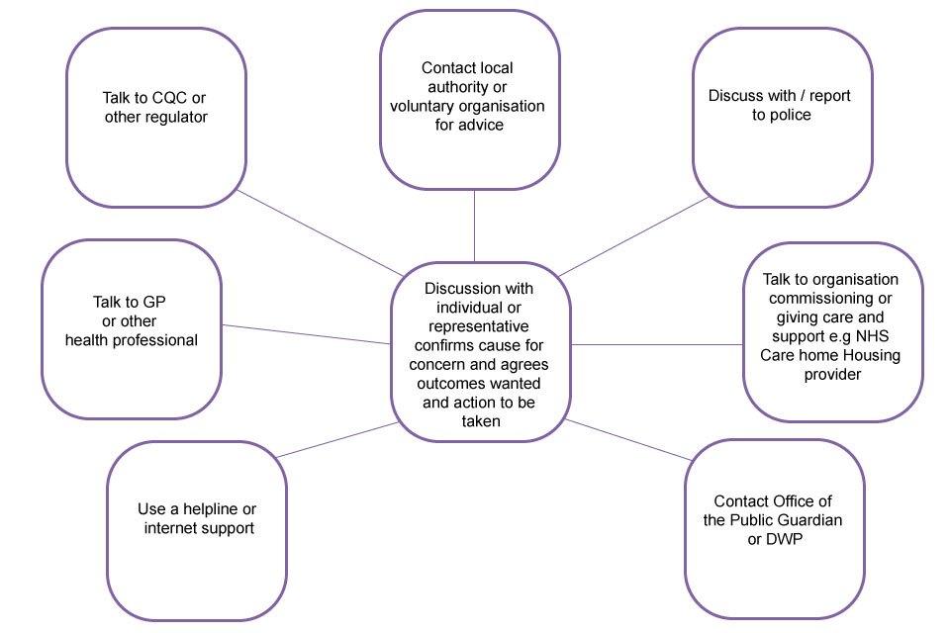
Safeguarding Advise and Initial Persons of Contact

(GOV UK 2016)

Appendix D

Adult Safeguarding Enquiry, Coordination, information Sharing and fact finding

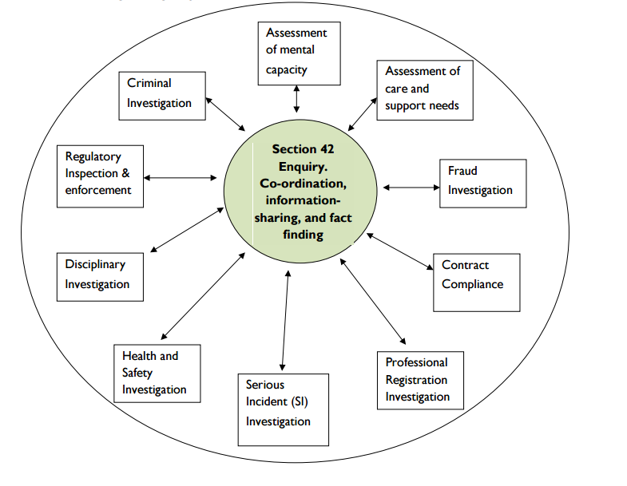

(West Midlands Adult Safeguarding Policy & Procedure 2015)
Referenced Diagram

Appendix E
Adult Safeguarding Procedure- Overview Flowchart

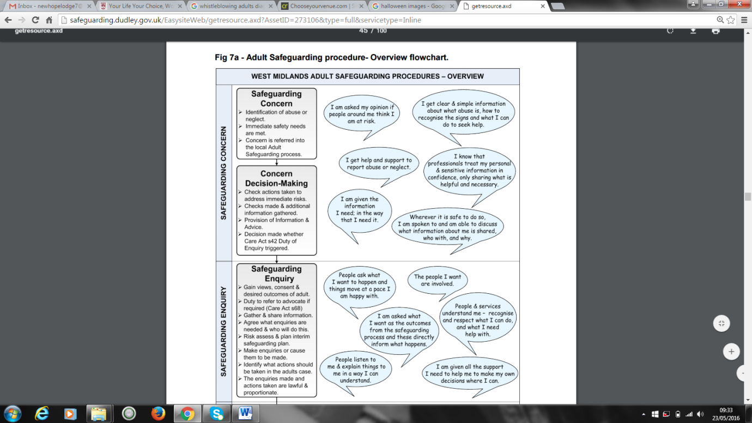

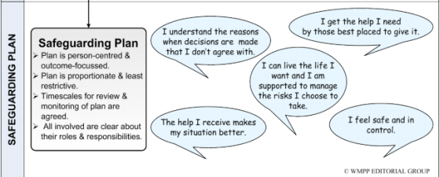

(West Midlands Adult Safeguarding Policy & Procedure 2015)
Referenced Flowchart

Appendix F
West Midland Adult Safeguarding Procedures-Guidance Flowchart
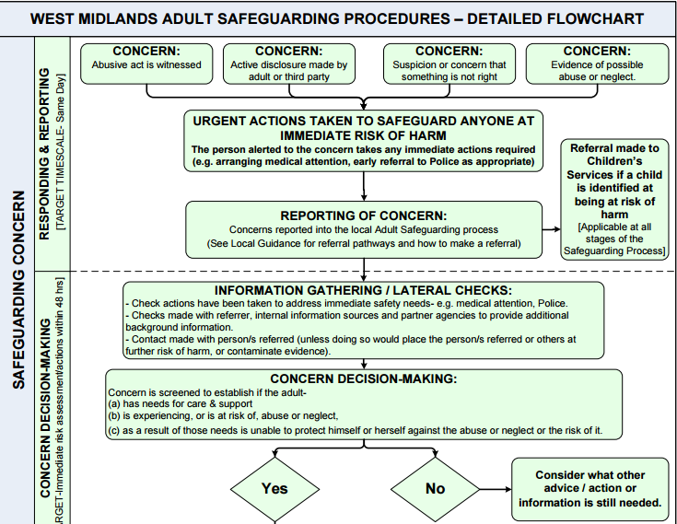
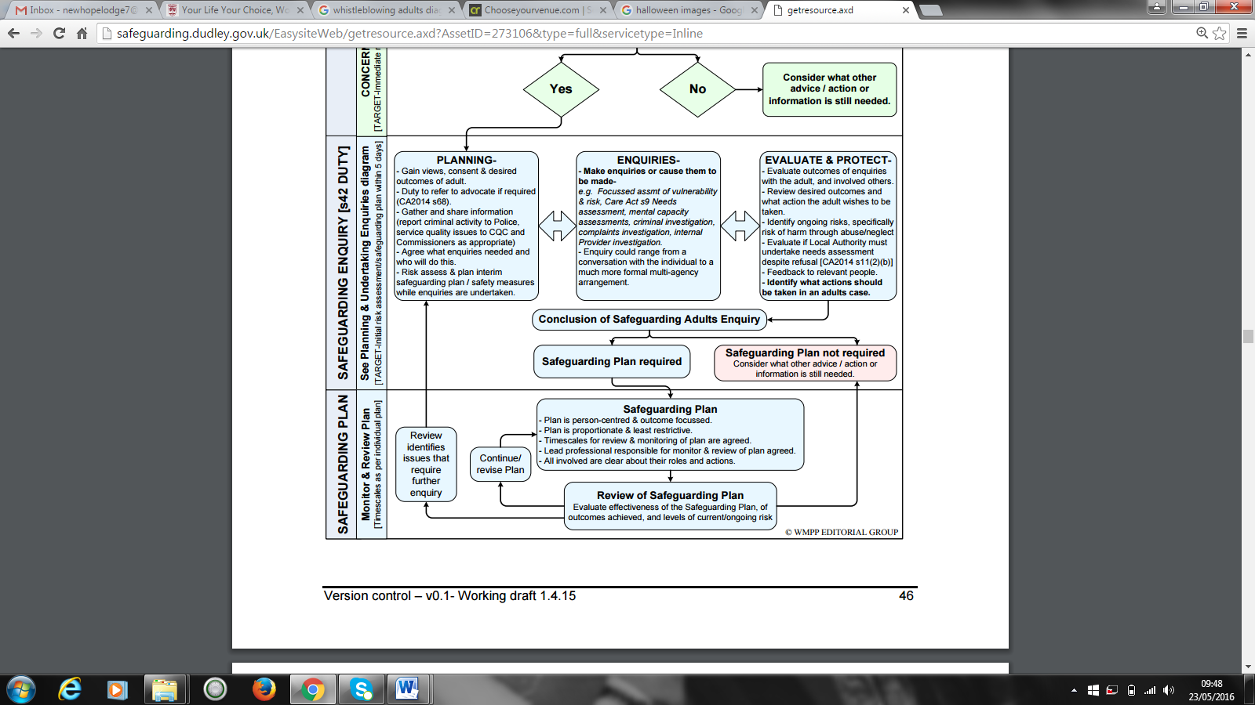

Appendix G
Adult Safeguarding Concerns: Responding & Reporting

(West Midlands Adult Safeguarding Policy & Procedure 2015)
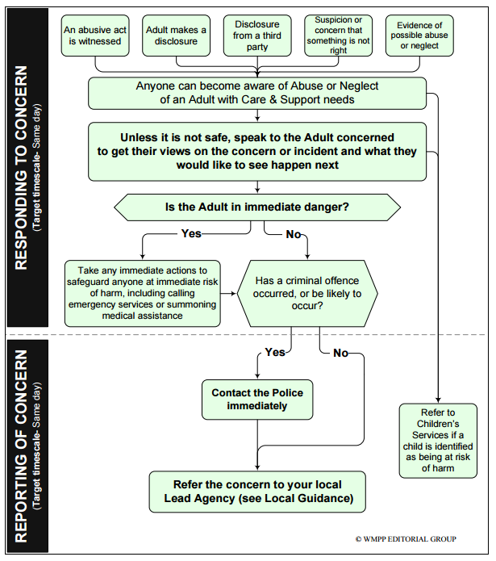
Referenced Flowchart

